## **ATP Window Defender**

## **Pre-requisites:**

* ATP setup file ' WDATPOnboard_NECTI_v2.0.exe' setup file must be downloaded.

URL: https://www.microsoft.com/en-in/download/details.aspx?id=54795

NECI has used the binaries shared by IT team and it is used in Fresher Machine setup in NECI.

* User should have administrator rights to install the file ‘WDATPOnboard_NECTI_v2.0.exe’

## **Installation:**

* Log in to the machine where ATP window defender Installation will be installed.
* Go to the location where ' WDATPOnboard_NECTI_v2.0.exe' setup file is downloaded.
* Copy the ' WDATPOnboard_NECTI_v2.0.exe' setup file.
* Navigate to the specific directory where ' WDATPOnboard_NECTI_v2.0.exe' will be copied. (C:\Share\ATP)
* Double click on 'WDATPOnboard_NECTI_v2.0.exe'. After that a command prompt will be open, which shows that installation is in progress.

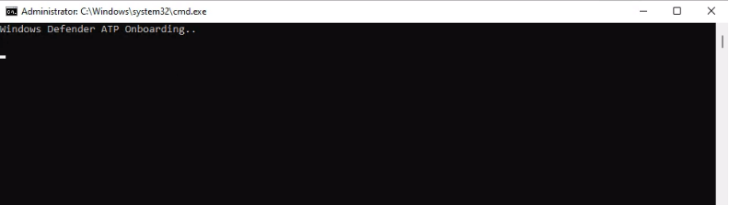

Fig 2.1.1 Installation start

* Now installation will be completed.

## **Verification:**

1. Log in to the machine where ATP has been installed.

2. Open 'Task Manager'.

3. Navigate to 'services' tab.

4. 'Sense' Service must be present in the list.

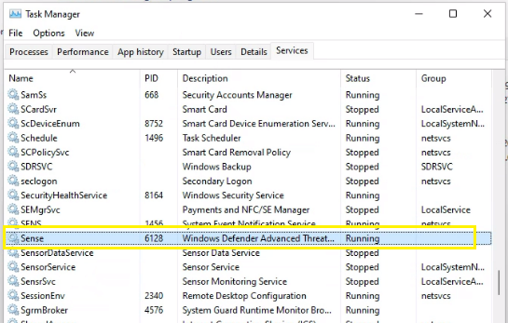

Fig 2.1.2 Installation status Check